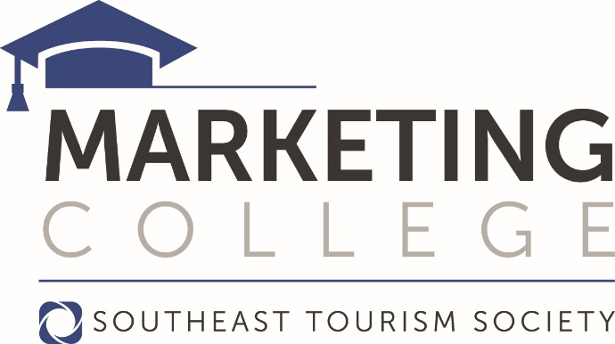

Johns Creek Convention & Visitors Bureau Director attends 26th Annual Southeast Tourism Society Marketing College

ATLANTA, Ga. (June 9, 2016)— Shelby Marzen, Executive Director if the Johns Creek Convention and Visitors Bureau joined more than three hundred tourism industry professionals, from across the United States, at Southeast Tourism Society’s (STS) 26th Annual Marketing College.

STS Marketing College is a nationally recognized, professional development program that, for one week each year, turns the facilities at University of North Georgia (UNG) in Dahlonega, Ga., into specialized classrooms to teach travel marketing. This year’s attendees were also treated to a special appearance by two of the Harlem Globetrotters during a reception hosted by UNG.

Enrollment for the three-year program was 304 this year which ran May 14 – May 19. The program began in 1992. Today, more than 1,000 travel and tourism professionals have completed the full curriculum and earned certification as a Travel Marketing Professional (TMP).

“Tourism is one of the leaders in job creation and has a positive economic impact on its communities,” said Bill Hardman, president and chief executive officer of STS. “At the same time, tourism is ever-evolving, and thus STS Marketing College was created as way to keep travel and tourism professionals ahead of industry trends.”

Students come from numerous industry sectors such as convention and visitor bureaus, chambers of commerce, attractions and hotels. Course topics include digital marketing, media relations, customer service, tourism advertising, vacation research, and crisis management.

“Our curriculum is practical and evolves with the attendee. Whether you’ve been in the industry for 30 days or 30 years, everyone walks away with new ideas and best practices for their destination,” Hardman said. “The knowledge gained at STS Marketing College can truly be applied anywhere. We have more than 1,000 graduates, throughout the United States, that can confirm the positive impact this program had on their career, in addition to their destination, as well as the friendships made.”

About Southeast Tourism Society (STS)
Founded in 1983, the Southeast Tourism Society (southeasttourism.org) is dedicated to promoting and developing tourism to and within its 12 member states of Alabama, Arkansas, Florida, Georgia, Kentucky, Louisiana, Mississippi, North Carolina, South Carolina, Tennessee, Virginia and West Virginia.

###
Media Contact:
Wendy Thomas
Wendy@southeasttourism.org
770-542-1523

